COMMUNICATIONS WORKING GROUP

Progress check 28th August 2023

WHATSAPP COMMUNITY

The framework for the WhatsApp community has been setup by Shona and Mags … and it has been tested.

The next stages are to agree the implementation with the Committee (probably in September), followed by the preparation of a communication to be sent out across the club to outline what is happening, when it is happening and what everyone should expect.

After that it is then the process of coordinating the admin of it to ensure we control who is joining.

WEEKLY BULLETIN / MONTHLY MAGAZINE

The general principles have been agreed between Sak, Bob and Alan. It is anticipated that there will be some fine tuning as we work through the pilot versions.

We are in general agreement to move ahead with the concept of a smaller focused Weekly Bulletin with 'live & active information' combined with a larger Monthly Magazine with longer-term programme and sociable information.
- The draft guidelines as to what would go in the Bulletin and what would go in the Monthly Magazine are in the attached document
- Road Closure alerts could be distributed via the Ride Leader Group WhatsApp and to Facebook
- The Weekly Bulletin could have a pointer for New Members as to where to go to get information on engaging with the Club
- Regular features such as the Quiz would be done once per month rather than Weekly.
- Alan Jelley will edit the Monthly Magazine. He will go on the Bulletin@ctccoventry.org.uk mailing list so there will not need to be any change for contributors

The General Approach is
The following is a possible Rollout approach and timetable

In October
- Carry on with current Weekly Bulletin format
- At the end of the month produce a draft Monthly Magazine copying the appropriate longer term programme and sociable content information from that months four Weekly Bulletins.
- Review with the Communications Working Group

In November
- Carry on with current Weekly Bulletin format
- At the end of the month produce a draft Monthly Magazine copying the appropriate information from that months four Weekly Bulletins.
- Produce one or two draft copies of previously issed Weekly Bulletins with the Longer term programme and Sociable content removed so they would reflect the new focused version
- Review with the Communications Working Group
- Review with the Committee for Implementation

In December
- Carry on with current Weekly Bulletin format
- Announce the change to the Club . Attach draft copies of the new focused Bulletin and the Monthly Magazine that were produced in November as examples.
- Confirm Rollout with the Committee

In January
- Start issuing just the new focused Bulletin each week
- Collect up the Longer term programme and Sociable content and produce a Monthly Magazine at the end of the month.
- Confirm that nothing is falling through the cracks

The current working guidelines are -

General principles or guidelines
If it is something that a member has to take action on that week (possibly fortnight) it goes in the Weekly Bulletin

If it is an addition or update to an ongoing Activity Programme it goes in the Monthly Magazine

If it is a Long-term Rolling Programme (Clubroom programme, Tours Programme)it goes on the Website

If it is static data it goes on the website

Immediate social media information e.g. Day Ride reports, go to Facebook

Tour reports, Womens Event Reports, Social Events Reports, Advocay Reports go in the Monthly Magazine,

IN THE WEEKLY BULLETIN

This weeks rides
Any specific road closures relevant to the week
Any Special rides key events relevant to the fortnight

Tours
Any Tour key events
Deadlines for bookings

Womens Group
Any Women's Group key events

Social
Social events with upcoming deadlines
Imminent Winter Clubroom events

Advocacy
Currently active campaigns with deadlines

Ride Reports
Any Rides reports from the previous weeks rides

IN THE MAGAZINE

Rides Programme

Reminder link to the Rides Schedule
Upcoming Special events
Ride Leader Group News

Touring
Reminder link to the Tour Programme
New tours recently added / amended

Completed Tours and pointer to Reports further on in the edition

Women's Group
Reminder link to Women's Group page
Womens Group News
Upcoming Womens Events

Completed Womens Events and pointer to Reports further on in the edition

Social Programme
Reminder link to the Social Programme
New Events recently added / amended

Completed Events and pointer to Reports further on in the edition

Advocacy
Reminder link to Advocacy on the website
New Advocacy campaigns

Ride Leader Group
Things the Group is working on
Rides / Tours change to rules, policies, riding guidelines, etc

Club Management
What the Committee is doing
Link to the latest Committee meeting minutes

Articles of general interest
... Submitted by members

Technical articles
Request articles on Technical Matters, Navigation devices, etc

Reports at the back of the Magazine

Any rides reports from the previous month not published in the Weekly Bulletin
Tour Reports
Womens Events Reports
Social Event Reports

NEW RIDER TRACKING PROCESS

Marina and I have made some good progress on the New Rider Tracking process and mechanism, in producing some sample letters to be set out at each checkpoint stage, and in developing an online questionnaire for riders who drop out. Currently we have a number of New Riders in the ‘system’ that we are tracking and will be piloting through the process.

1. TRACKING PROCESS AND SHEET
This is the Tracking Spreadsheet with the process flowing from left to right across the columns. There is an explanation of what happens at each stage / column.

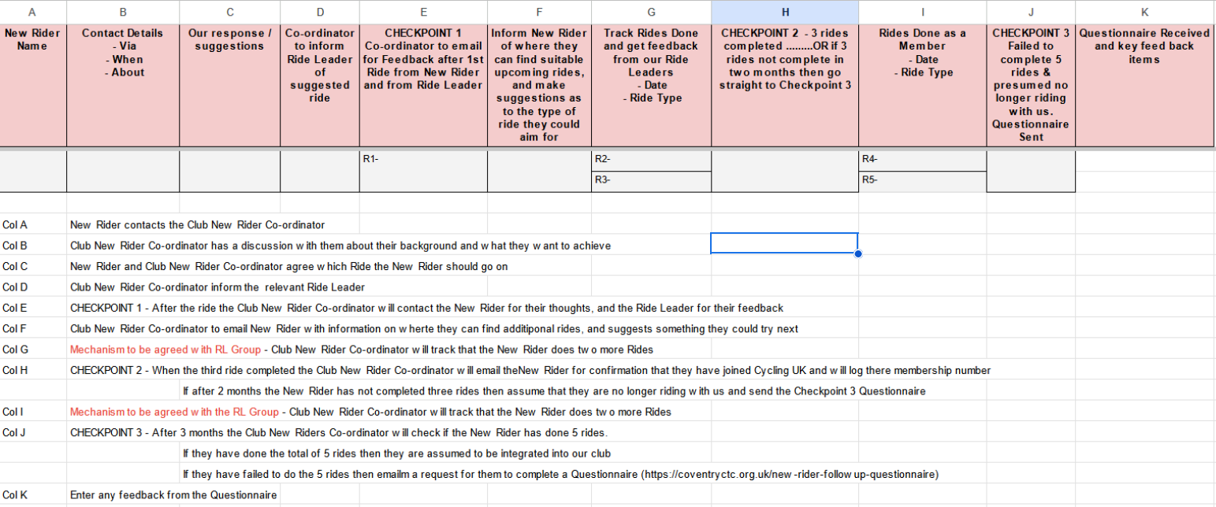

2. SAMPLE LETTERS
These are three sample emails that the New Rider Co-ordinator could use as the basis for communicating with new riders as they progress through their initial rides with us and are tracked using our New Rider Tracking process.

Sample followup email after their first ride with us – CHECKPOINT 1

Dear ?????

It was great to have you cycle with our Club on your recent ride on the %%%%% out to ********. This is a followup note from our New Rider Co-ordinator to check if the ride met your expectations and if you had an enjoyable experience ?

- Was the ride what you expected ?

- Did we make it an enjoyable experience for you ?

We hope that you are looking forward to riding with us again ? Do you know the ride you’d like to do ? And if not would you like to discuss with us the sort of ride that would suit you best ?

However if you are unlikely to ride with us again we would appreciate your thoughts on what we could have done to make it a better match with your expectations ?

Sample followup email after their third ride with us – CHECKPOINT 2

Dear ????

It has been was great to cycle with you on your recent rides with us on the ????? and ?????.

We hope that you will continue to cycle with us on many more rides and maybe come along on our tours !

For Insurance reasons we are not able to have anyone ride with us as a Guest on more than three occasions so if you do feel like that you wish to continue riding with us then we ask you become a member of Cycling UK. There are many benefits to becoming part of the Cycling UK ‘community’ and whilst there is a fee we all feel that the benefits are significant and important.

To join then please follow this link - https://www.cyclinguk.org/join-cycling-uk-today

When you have completed the joining process then please let us know your membership number.

(Note that if you wish to carry on riding with us before the joining process has completed &/or your membership number has arrived then please let us know and we will be flexible)

If you feel that you do not wish to continue then we understand and wish you all the best in your future cycling.

Sample followup email after they have not completed 5 rides with us in 3 months – CHECKPOINT 3

Dear ???

We have noticed that you have not been cycling with us recently and we would like to check how you are and if there is anything we can do to assist you back to our Club or on your bike ?

However if you are unlikely to return to cycling with us then that is a shame and we are sorry if we have failed to meet you expectations. We would appreciate it if you complete a simple online questionnaire form for us to understand in what way we have not met your expecations and what improvements could make riding with us more attractive to you ?

This is the questionnaire on our website - → https://coventryctc.org.uk/new-rider-followup-questionnaire

We appreciate any effort you make to help us.

FACEBOOK AND INSTAGRAM

This is an area that we are struggling with somewhat.

None of us seem to be major users of Facebook or Instagram and some are even anti-users ! To realistically assess where these two could fit into our Communications 'profile' then we probably need some strong users or advocates of social media from outside of our group to come in and help us.

Does anyone have any suggestions of likely candidates ?

